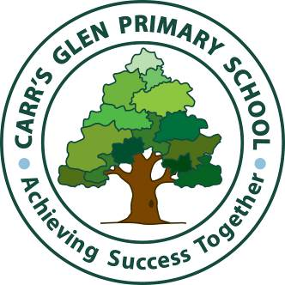
Carr’s Glen Courier
Number 572 Friday 4th February 2022
Tel:(028)90391286 Website: www.carrsglenps.com
Fax (028) 9071 4303 E-mail: info@carrsglen.belfast.ni.sch.uk

IMPORTANT DATES

Half Term - Monday 14th - Friday 18th February (inclusive)

Thursday 17th March - OFF St. Patrick’s Day

School finishes for Easter on Tuesday 12th April (12 noon finish, no meals provided)
Easter Break - Wednesday 13th - Friday 22nd April (inclusive)

PLEASE NOTE we are now a polling station and school will be closed Thursday 5th May 2022

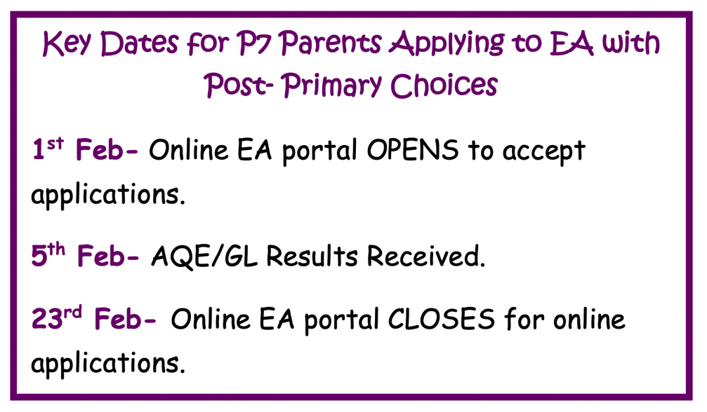
Tuesday 8th February
Safer Internet Day

Thursday 10th February
100th Day

REMINDER
Arriving on time to school is essential, so pupils are prepared and organised for their learning. It can also help them to avoid feelings of anxiety when entering their classroom late and then having to catch up on the learning missed. We would encourage you to please have your child in school before 9.10am each day.

We also recognise that there are times when absence is unavoidable. In those cases we would remind you that we require a reason for the absence. Please remember to send the teacher a message on Seesaw, write a note or phone the office.

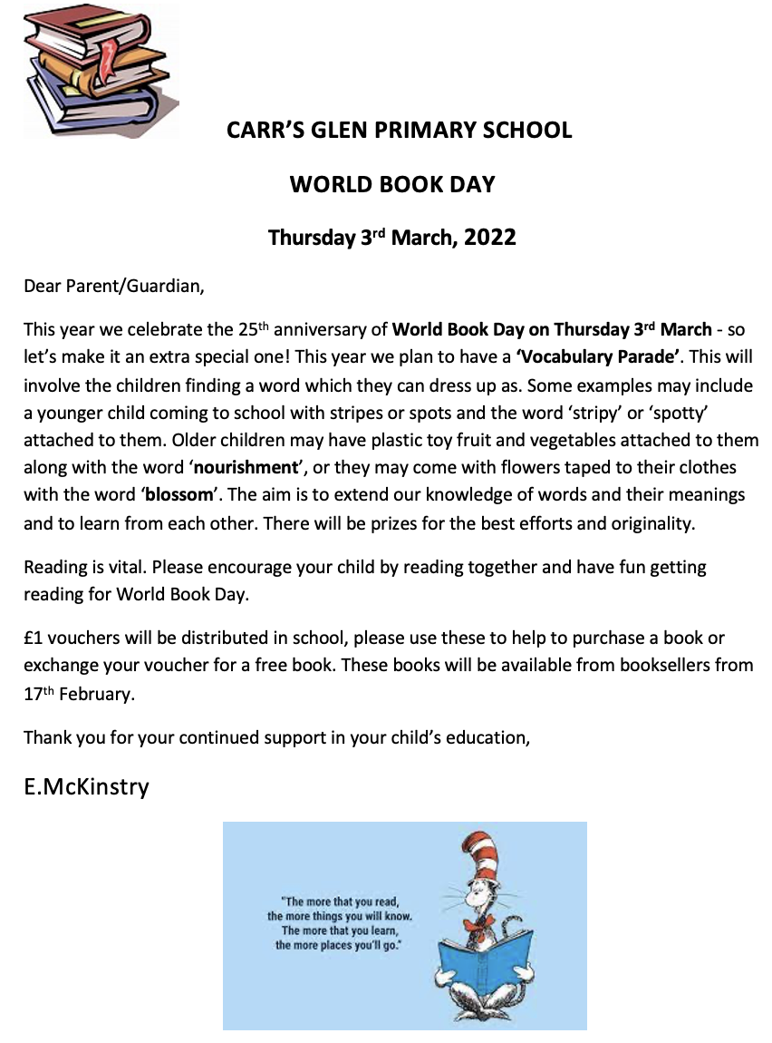

School Dinners

If your child is taking School dinners this should be paid on a Monday each week. Please have money in an envelope, labelled clearly with the days and your child’s name.
Thank you

