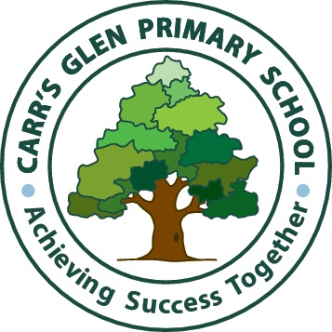
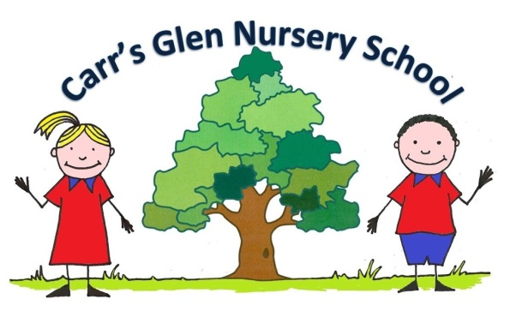
Carr’s Glen Primary School
FREE online education resources
(ideas taken and modified from Whiteabbey Primary with permission)
A non-exhaustive list that might help those affected by school closures due to coronavirus, compiled by home educators.
Feel free to share.

BBC Learning
http://www.bbc.co.uk/learning/
This site is old and no longer updated and yet there's so much still available, from language learning to BBC Bitesize for revision. No TV licence required except for content on BBC iPlayer.

Blockly
https://blockly.games
Learn computer programming skills - fun and free.

Reading books – lots of fact books and topic books
https://readon.myon.co.uk/library/browse.html

Scratch
https://scratch.mit.edu/explore/projects/games/
Creative computer programming

Ted Ed
https://ed.ted.com
All sorts of engaging educational videos

National Geographic Kids
https://www.natgeokids.com/uk/
Activities and quizzes for younger kids.

Duolingo
https://www.duolingo.com
Learn languages for free. Web or app.

Mystery Science
https://mysteryscience.com
Free science lessons

The Kids Should See This
https://thekidshouldseethis.com
Wide range of cool educational videos

Crash Course Kids
https://m.youtube.com/user/crashcoursekids
As above for a younger audience
iDEA Awards
https://idea.org.uk
Digital enterprise award scheme you can complete online. – More for Y6/7 and Secondary School

Tinkercad
https://www.tinkercad.com
All kinds of making.

Prodigy Maths
https://www.prodigygame.com
Is in U.S. grades, but good for UK Primary age.

Cbeebies Radio
https://www.bbc.co.uk/cbeebies/radio
Listening activities for the younger ones.

Nature Detectives
https://naturedetectives.woodlandtrust.org.uk/naturedetect…/
A lot of these can be done in a garden, or if you can get to a remote forest location!

Oxford Owl for Home – Y2-6 should have received logins
https://www.oxfordowl.co.uk/for-home/
Lots of free resources for Primary age

Geography Games
https://world-geography-games.com/world.html
Geography gaming!

Red Ted Art
https://www.redtedart.com
Easy arts and crafts for little ones

The Imagination Tree
https://theimaginationtree.com
Creative art and craft activities for the very youngest.

Toy Theater
https://toytheater.com/
Educational online games

DK Find Out
https://www.dkfindout.com/uk/…
Activities and quizzes

Twinkl
https://www.twinkl.co.uk
This is more for printouts, and usually at a fee, but they are offering a month of free access to parents in the event of school closures.

