CARR’S GLEN PRIMARY AND NURSERY SCHOOL
629 Oldpark Road
Belfast
BT14 6QX
02890391286
www.carrsglenps.com
Principal: Mr J Todd
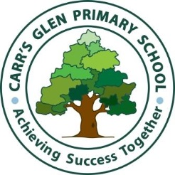
Tuesday 11th August 2020
Restart of School
Dear Parents/Carers,
I hope you and your families are well during these challenging times. Last Thursday 6th August, the Executive agreed that the guidance for reopening schools should be revised to allow for the return of all pupils. The guidance is due to be published later this week. We will give you more specific details on the school return once the guidance is published. We have been working hard to prepare for the return of the pupils and below is a summary of some of the main changes to the school day:

- Staggered arrival and departure times for pupils;
- Use of other entrance / exit points;
- Each class to function as a ‘protective bubble’;
- Each class to have designated route within the school when moving about;
- Adapting our learning approaches;
- Playground zones for classes;
- Greater use of outdoor opportunities for learning;
- Procedures for managing pupils and staff who display symptoms of Covid 19;
- Procedures for communicating / managing any confirmed cases of Covid 19 within the school community;
- Enhanced cleaning procedures;
- Revised first aid procedures;
- Revised procedures for safeguarding and positive behaviour policy;
- New office / visitor procedures.

Our highest priority is the safety and wellbeing of our pupils and staff. I would like to thank you for your ongoing support during these challenging times.
Yours sincerely,
Mr J Todd
Principal

