CARR’S GLEN PRIMARY AND NURSERY SCHOOL
629 Oldpark Road
Belfast
BT14 6QX
02890391286
www.carrsglenps.com
Principal: Mr J Todd
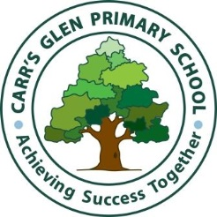
SCHOOL REPORTS 2019-2020
24th June 2020
Dear Parents/Carers,
This year’s school report is reflective of your child’s progress from September to March. The reports have been revised this year due to the early school closure at the end of March. It has not been possible to carry out the standardised tests which normally take place in May. The reports, therefore reflect the work carried out in class until school closed near the end of March.
Communication | Reading, Writing, Talking and Listening
Using Mathematics | Mathematical Knowledge and Skills
Other Areas of Learning  (Comments where relevant) | - Using ICT  - The World Around Us  - Personal Development and Mutual Understanding  - The Arts  - Physical Education

I want to thank you all for your hard work and dedication in assisting the school with remote learning. It has been an unforeseen and challenging end to the year. I trust that this report will be useful for you and your child and I will take this opportunity to again wish you a very happy and restful summer break.

Yours sincerely
Mr J Todd
Principal

